

Course: EEEN 222 Digital Systems Design

Instructor:

Exam/Date: Midterm Exam

Duration: 100 min.

İstanbul Bilgi University

Faculty of Engineering and Natural Sciences

Department of Electrical and Electronics Engineering

|  |  |  |  |  |  |
| --- | --- | --- | --- | --- | --- |
| Problem | 1 | 2 | 3 | 4 | Total |
| Maximum score | 25 | 25 | 25 | 25 | 100 |
| Course Learning Outcome | 1 | 1, 2 | 1, 2 | 1, 2 |  |

**Problem 1)** Consider a general Boolean algebra and use the axiom(s) and/or theorems of the general Boolean algebra to prove the following identities:

1. $Y+X^{'}Z+XY^{'}=X+Y+Z$**(10 points)**
2. $A^{'}B^{'}+B^{'}C+AC+AB+BC^{'}=A^{'}B^{'}+AC+BC'$**(15 points)**

**Problem 2)** Given the logic circuit below,

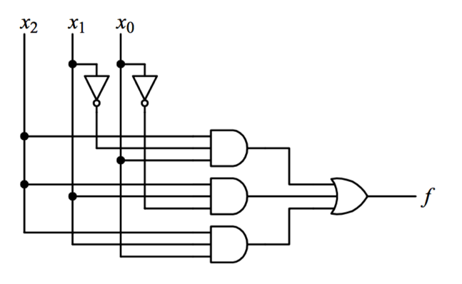

1. Find the Boolean function *f* (*x2,x1,x0*) implemented by the logic circuit **(5 points)**.
2. Derive the truth table for the function *f* (*x2,x1,x0*) **(7 points)**.
3. Simplify the function *f* (*x2,x1,x0*) by applying Karnaugh Map method **(8 points)**.
4. Implement the simplfied function using only NAND Gates **(5 points)**.

**Problem 3) (25 points)** For the following function

$$F\left(A,B,C,D\right)=∑\left(0,3,5,6,7,10,12,13\right)+d(2,9,15)$$

1. Simplify the function $F\left(A,B,C,D\right)$ using Karnaugh-Map method **(15 points)**
2. Implement the simplified expression using only NOR Gates **(10 points)** .

**Problem 4) (25 points)** A combinational logic circuit is defined by the following Boolean function

$$F\left(A,B,C,D\right)=AB+BC^{'}D^{'}+A^{'}BC+C'D$$

1. Using an appropriate minimum size decoder and an external NAND gate, draw a logic circuit diagram that implements $F\left(A,B,C,D\right)$**(10 points)**.
2. Implement the Boolean function $F\left(A,B,C,D\right)$ using only a 4-to-1-line multiplexer and external NOR gate(s) if necessary **(15 points)**.